**Lab Practical #04:**

Installation of Network Simulator (Packet Tracer) and Implement different LAN topologies.

**Practical Assignment #04:**

1. **Create a simple network with switch and two or more pc. Also check connectivity between them using ping command or PDU utility.**

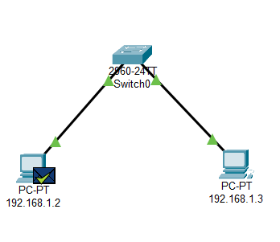 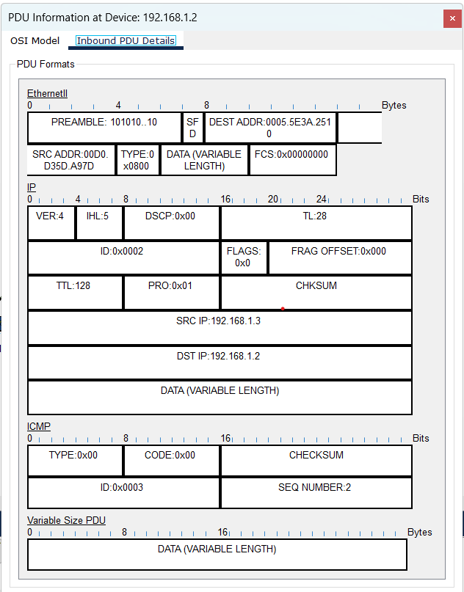

1. **Implement different topologies in packet tracer.**
   1. **Bus**
   2. **Ring**
   3. **Star**
   4. **Mesh**
   5. **Tree**

**Instructions:**

1. Topology-wise Screenshot.
2. Mention IP address of each pc as label.
3. Ping command or PDU screenshot between two pcs.
4. **Bus**

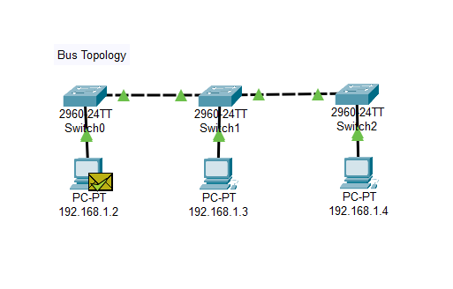

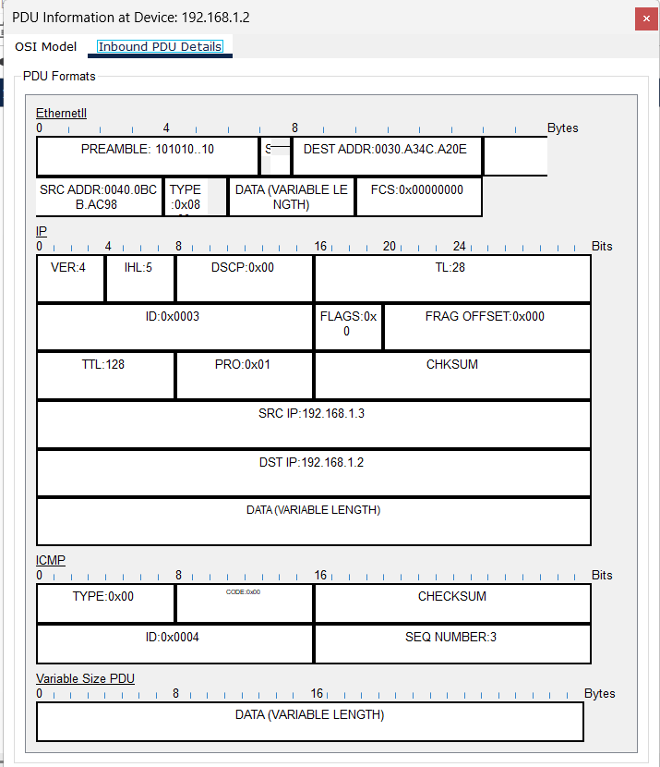

1. **Ring**

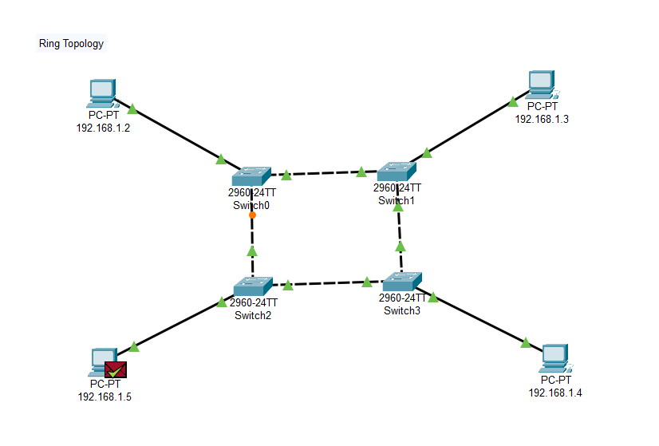

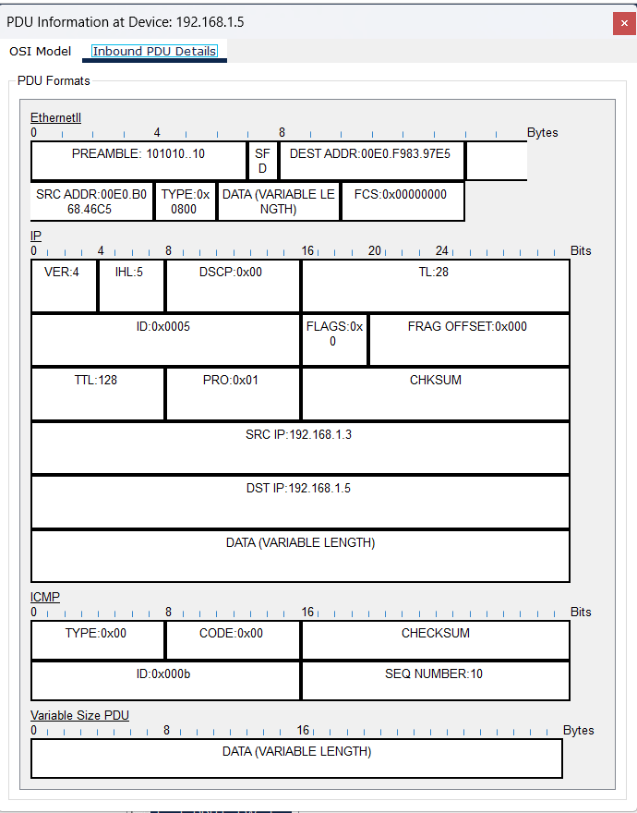

1. **Star**

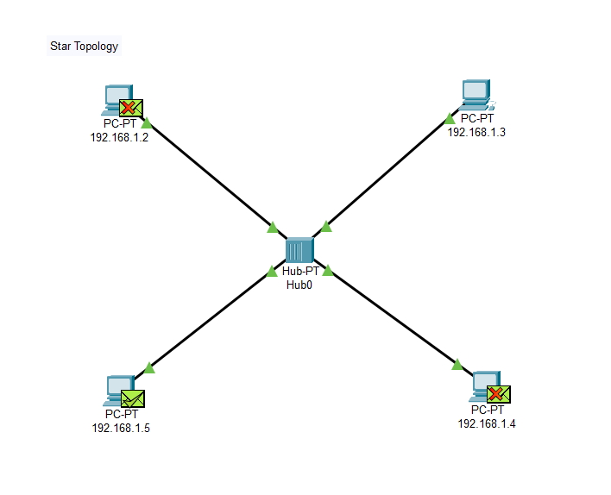

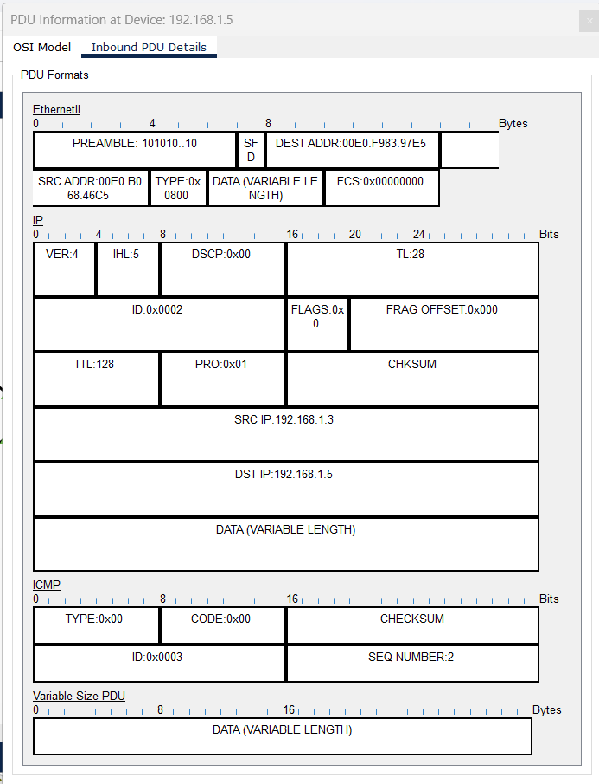

1. **Mesh**

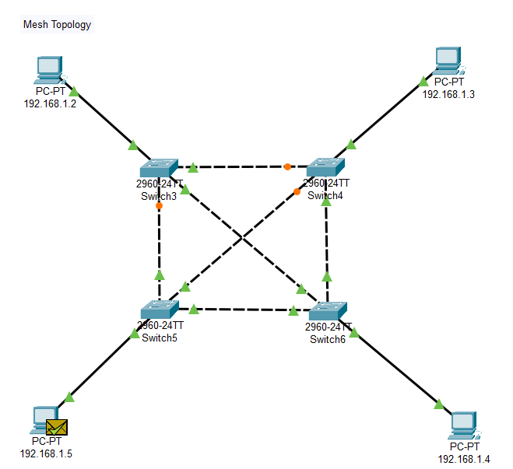

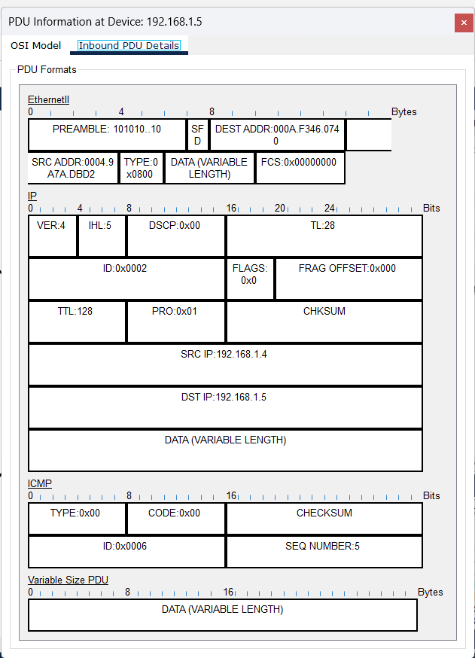

1. **Tree**

